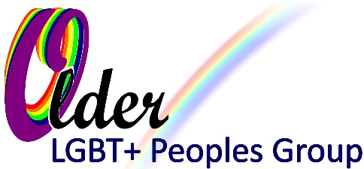
North Midlands LGBT+ Older Peoples Group
Registered Charity 1186844
Web: olgbtstoke.org.uk
Email: olgbt2009@gmail.com

Membership Application
Membership of the North Midlands LGBT Older Peoples Group is open to all LGBT+ adults and others who share our aims. You just need to join our mailing list and come along to some of our meetings either in person or online then complete below to apply.
Your application will be approved by the board of Trustees at their next monthly meeting as long as you meet the requirements for membership.
Please note your personal contact details will be kept confidentially by our board of Trustees. We only require your name and an email address; other details are optional.
We do not make assumptions about the reasons that people identify with our community, and we do not ask you state your sexual orientation or gender when you join our group.
Name (required)
Email address (required)
We will send regular updates about our meetings and activities to this email address.
Mobile Phone (optional)
Would you like to join our WhatsApp Chat Group - Yes / No
(If yes please make sure you have given us your mobile number above)
Home Phone (optional)
Home Address (optional)

Other contact details (optional)
I wish to become a member of the LGBT Older People’s Group and agree to abide by its constitution and policies.
Signature:
Date:
Thank you for your interest in becoming a member

